* <https://docs.microsoft.com/en-us/azure/azure-monitor/overview>
* 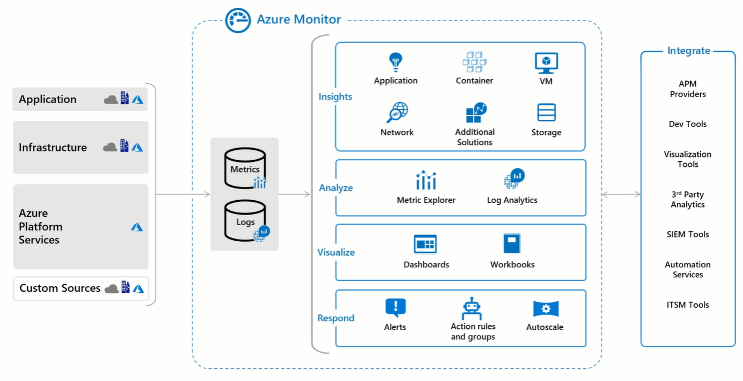
* Enable VM Monitoring in Azure
* 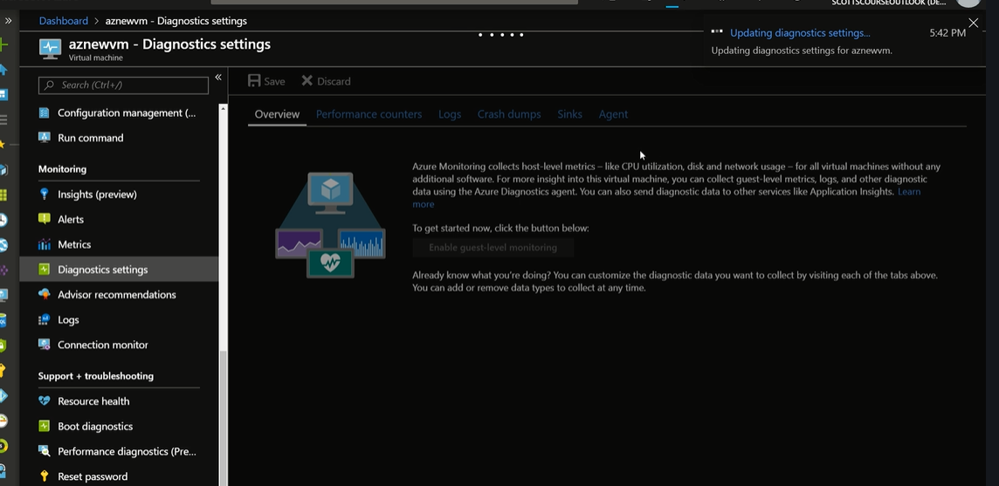
* It installs the agent which get the logs and details to the Azure portal.

**Function App Log**

* Turning on application insights to support logs.